Question | Type of Test | Non-Parametric Analog | Steps
Is the mean different from X (target or standard) | t-test - Assumes normality | 1-sample-sign – performs a one-sample sign test of the median and calculates the corresponding point estimate and confidence interval.  1-sample Wilcoxon – performs a one-sample Wilcoxon signed rank test of the median and calculates the corresponding estimate and confidence interval. | - Collect random sample  - Measure sample  - Calculate x-bar, s  - Produce a probability plot, check P value > 0.05  - For non-normal data use median or transform data to make it normal  - Use the confidence interval for the mean  - If X is in the confidence interval, fail to reject the null hypothesis
Are two sample means different? (between group means) | 2 Sample t-test - Assumes normality and equal variance | Mann-Whitney – performs a hypothesis test of the equality of two population medians and calculates the corresponding point estimate and confidence interval. | - Collect random sample  - Measure sample  - Calculate x-bar, s for both samples  - Produce a probability plot, check P value > 0.05  - For non-normal data transform data to make it normal or use a non-parametric test  - Calculate the difference between the two means  - Use the confidence interval for the mean  - If zero lies within the confidence interval, fail to reject the null hypothesis
Are all of the means consistent with a common process mean? | ANOM | For non normal data use median and Kruskal-Wallis test | - Collect historical data  - Evaluate using ANOVA, Analysis of means
Are all of the means the same? | ANOVA - ANOVA requires mutually independent random samples drawn from normal distributions that have equal variances. | Kruskal-Wallis – performs a hypothesis test of the equality of population medians for a one-way design (two or more populations).  If P less than .05, reject the null hypothesis that the medians are the same.  Use the box plot to review the data  Mood’s median test – performs a hypothesis test of the equality of population medians in a one-way design. Sometimes called a median test or sign scores test. | - Collect random sample  - Produce a probability plot, check P value > 0.05  - Choose the level of significance alpha=.05  - Compute F statistic  - Compare computed F to critical F  - IF computer F > critical F, then reject the null hypothesis  - Determine if the residuals are normal using the probability plot
Did my change make a difference for the individual subjects? (don’t care about between subjects) | Paired t-test | If data not normal use the Wilcox rank test | - Collect random sample  - Measure sample  - Make the change you are interested in studying  - Repeat the measurement  - Analyze the differences  - Calculate x-bar, s for both samples  - Produce a probability plot, check P value > 0.05  - Run the Paired t-test. If the mean difference is zero, fail to reject the null hypothesis
Are there differences in this table? | Chi-square test
Are these means different from one another with respect to two variables? (not possible to obtain repeat readings) | Two Way ANOVA with no replicates | Experimental treatments assigned at random | P value < 0.05 indicates there is a significant effect
Are these means different from one another with respect to two variables and their interactions? (you can obtain more than one result for each combination of treatments) | Two way ANOVA with replicates | Friedman – performs a non-parametric analysis of a randomized block experiment. Requires exactly one observation per treatment-block combination.
Are all of these means consistent with a common mean with respect to two variables? | Two-way ANOM
Do these groups differ with regard to the proportion of items in the categories? Compare the percentage of items distributed among several categories.
 | Linear Regression  Response variable is interval or ratio |  | Choose predictor variables  Create model using all Xs.  Review the VIF to make sure it it small. VIF > 10 indicates 90% of X is explained by the other Xs in the model. VIF>5 indicates 80%.  Drop Xs with high VIF until all remaining Xs have a VIF < 10  Perform a best subsets regression with remaining variables.  Cp less than number of predictors + 1  S small  Rsq large  P < .05 or wrong sign on coefficient.  Examine residuals to look for outliers
 |  | Run test – tests whether or not the data order is random.
 |  | Pairwise averages – calculates and stores the average for each possible pair of values in a single column, including each value within itself. Used for the Wilcoxon method.
 | Simple linear regression | Pairwise slopes – calculates and stores the slope bwtween all possiblr pairs of points. Useful for finding robust estimates of the slope of a line through the data.
 |  | Pairwise differences – calculates and stores the differences between all possible pairs of values formed from two columns. Useful for non-parametric tests and confidence intervals.
Bartlett’s test |  | Levene’s test – tests for equal variances. This method considers the distances of the observations from their sample median rather than the mean. More robust for smaller samples.
 |  | Non-parametric distribution analysis – analyzes times-to-failure when no distribution can be found to fit the (censored) data.
Hazard plots |  | Hazard plots – if data are right censored, plots empirical hazard function or actuarial estimates.

Use non-parametric tests when:
- The data are counts or frequencies of different types of outcomes.
- The data are measured on the nominal or ordinal scale.
- The assumptions required for the validity of the corresponding parametric procedure are not met or cannot be verified.
- The shape of the distribution is unknown.
- The sample size is small.
- The measurements are imprecise.
- There are outliers and/or extreme values in the data, making the median more representative than the mean.
Use parametric when both of the following are true:
- The data are collected and analyzed using the interval or ration scale of measurement.
- All of the assumptions required for the validity of that parametric procedure can be verified.

Linear Regression in Minitab
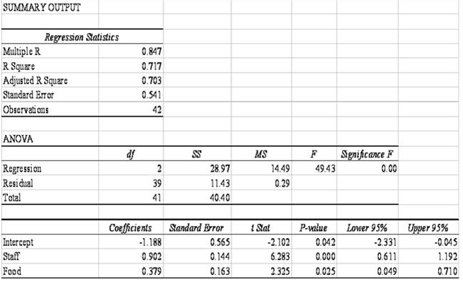
Multiple R - Multiple correlation coefficient, responses are highly correlated.
R square – the fitted equation explains 71.7% of the total variation
Adjusted R square – adjusted for degrees of freedom
Standard error – standard deviation of the error of the residuals
Significance F – the probability of getting these results by chance alone is < .005
Rating = -1.188 + .902*Staff + .379*Food
Standard error – standard deviation of each term
T Stat – how many standard deviations the observed coefficient is from zero
P value < .05 indicates the coefficient is significantly different from zero
Lower and upper 95% - if it doesn’t include zero, reject the null hypothesis the coefficient is significantly different from zero

